Signals and Systems 1
- Time scaling $x\left(t\right)→x\left(at\right)$ divides the time axis by $a$.
- When more than one transformation is combined (e.g. $x\left(-2t-1\right)$, the easiest order is:
  - Time shift
  - Time scale
  - Time reverse
- Signal types according to power and energy:
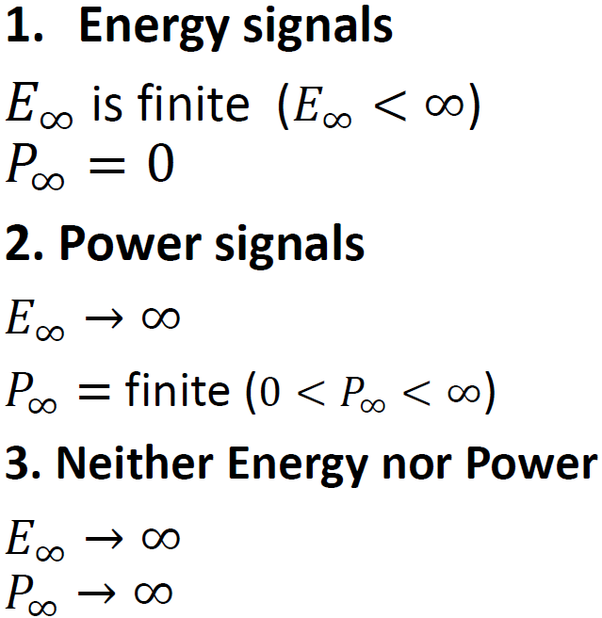
- All periodic signals are power signals.
- For an odd signal, $x\left(0\right)=0$.
- Any signal $x\left(t\right)=x_{e}\left(t\right)+x_{o}\left(t\right)$, where:
  - $x_{e}\left(t\right)=\frac{x\left(t\right)+x\left(-t\right)}{2}$
  - $x_{o}\left(t\right)=\frac{x\left(t\right)-x\left(-t\right)}{2}$
- A unit step signal is neither even nor odd, and it’s a power signal.
- A unit impulse signal is even, and it’s neither energy nor power signal.
- Relationship between unit step and unit impulse:
  - $u\left(t\right)=\int_{-∞}^{t}{δ\left(τ\right)dτ}$
  - $δ\left(t\right)=\frac{du\left(t\right)}{dt}$
- What is a memoryless system?
  - A system is memoryless if the output at a given time depends only on the input at the same time but not in past times.
- What is a causal system?
  - A system is causal if the output at a given time depends only on the input at the present and past times but not future.
- What is an invertible system?
  - A system is invertible if we can figure out an inverse system for it:
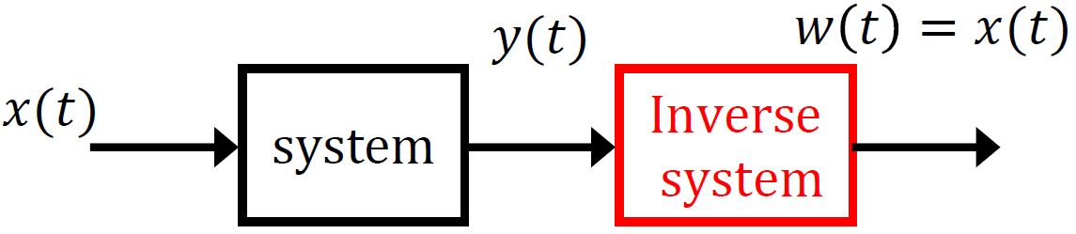
  - For this to be possible, the system must generate distinct outputs for distinct inputs; if the system can generate the same output for two different inputs, then it is non-invertible.
  - To prove that a system is non-invertible, show that it gives the same output for two different inputs.
  - To prove that a system is invertible, try to get $x\left(t\right)$ (i.e. the system’s input) as a function of $y\left(t\right)$.
- What is a linear system?
  - Linear = additive + homogenous
  - Additive: if $x_{1}\left(t\right)$ gives $y_{1}\left(t\right)$ and $x_{2}\left(t\right)$ gives $y_{2}\left(t\right)$, then $x_{1}\left(t\right)+x_{2}\left(t\right)$ should give $y_{1}\left(t\right)+y_{2}\left(t\right)$ if the system is additive.
  - Homogenous: if $x_{1}\left(t\right)$ gives $y_{1}\left(t\right)$, then $ax_{1}\left(t\right)$ should give $ay_{1}\left(t\right)$ if the system is homogenous.
  - Together: if $x_{1}\left(t\right)$ gives $y_{1}\left(t\right)$ and $x_{2}\left(t\right)$ gives $y_{2}\left(t\right)$, then $a_{1}x_{1}\left(t\right)+a_{2}x_{2}\left(t\right)$ should give $a_{1}y_{1}\left(t\right)+a_{2}y_{2}\left(t\right)$ if the system is linear.
- What is a time-invariant system?
  - If a system is time-invariant, then a time shift in the input should result in an identical time shift in the output. That is, if $x\left(t\right)$ gives $y\left(t\right)$, then $x\left(t-t_{o}\right)$ would give $y\left(t-t_{o}\right)$ if the system is time-invariant.
- Is an integrator system causal/non-causal and memoryless/with memory?
  - An integrator system is given by $y\left(t\right)=\int_{-∞}^{t}{x\left(τ\right)dτ}$, so it’s with memory and causal.
- Is $y\left(t\right)=x\left(-t\right)$ causal or non-causal?
  - Non-causal (try to put negative time values)
- Is $y\left(t\right)=\sin\left(x\left(t\right)\right)$ an invertible system?
  - If $x\left(t\right)=0$, then $y\left(t\right)=0$. If $x\left(t\right)=π$, then $y\left(t\right)=0$. Thus, non-invertible.
- Is $y\left(t\right)=x\left(2t\right)$ a time-invariant system?
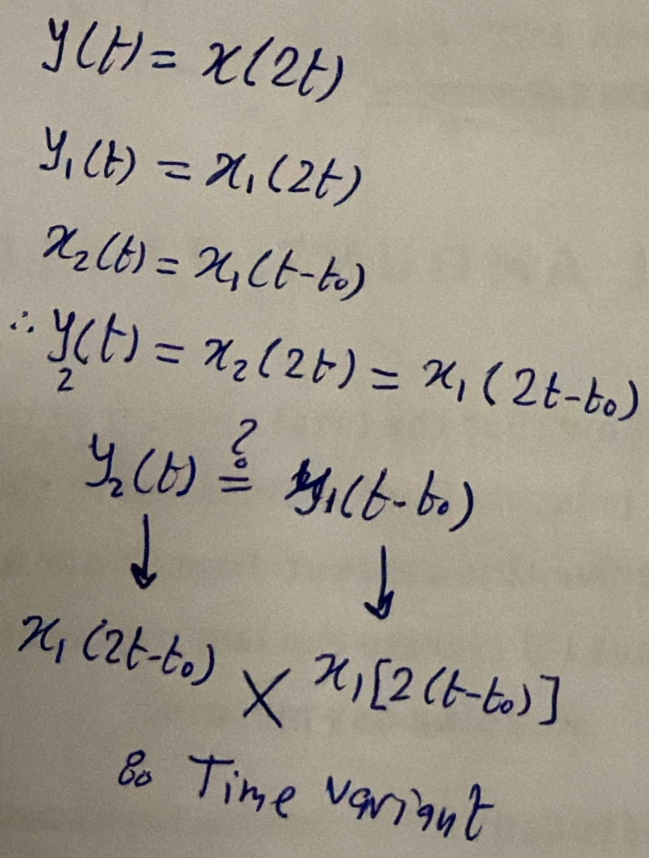
- If the input to a time-invariant system is periodic, the output will also be periodic with the same period.
- An LTI system is special because it is completely characterized by its impulse response $h$, which determines the output for any input via convolution in time or multiplication in frequency.
- For an LTI system:
  - $y\left(t\right)=x\left(t\right)*h\left(t\right)=\int_{-∞}^{∞}{x\left(τ\right)h\left(t-τ\right)dτ}$
  - The start of $y\left(t\right)$ is the sum of starts of $x\left(t\right)$ and $h\left(t\right)$, and the end of $y\left(t\right)$ is the sum of $x\left(t\right)$ and $h\left(t\right)$.
- $x\left(t\right)δ\left(t-t_{o}\right)=x\left(t_{o}\right)δ\left(t-t_{o}\right)$
- $x\left(t\right)*δ\left(t-t_{o}\right)=x\left(t-t_{o}\right)$
- LTI system properties from its impulse response $h\left(t\right)$:
  - An LTI system is said to be memoryless if $h\left(t\right)=kδ\left(t\right)$.
  - An LTI system is said to be causal if $h\left(t\right)=0$ for $t<0$.
  - An LTI system is said to be invertible if we can find $h_{i}\left(t\right)$ such that $h\left(t\right)*h_{i}\left(t\right)=δ\left(t\right)$ OR $H\left(ω\right)H_{i}\left(ω\right)=1$

Signals and Systems 2
- Discrete-time shabah bzbt el continuous-time, fa I will mention bs el 7agat el momken fiha e5telaf aw tafkeer.
- $t→n$
- $ω→Ω$
- Is the system $y\left[n\right]=\sum_{m=-∞}^{n}{x\left[m\right]}$ invertible?
  - $y\left[n\right]=y\left[n-1\right]+x\left[n\right]→x\left[n\right]=y\left[n\right]-y\left[n-1\right]$
  - Always remember that the accumulator and difference systems are the inverse of each other (just like differentiator and integrator systems).
- If a sequence of length $N_{1}$ is convolved with a sequence of length $N_{2}$, then the output sequence is of length $N_{1}+N_{2}-1$.

Internship – Session 1
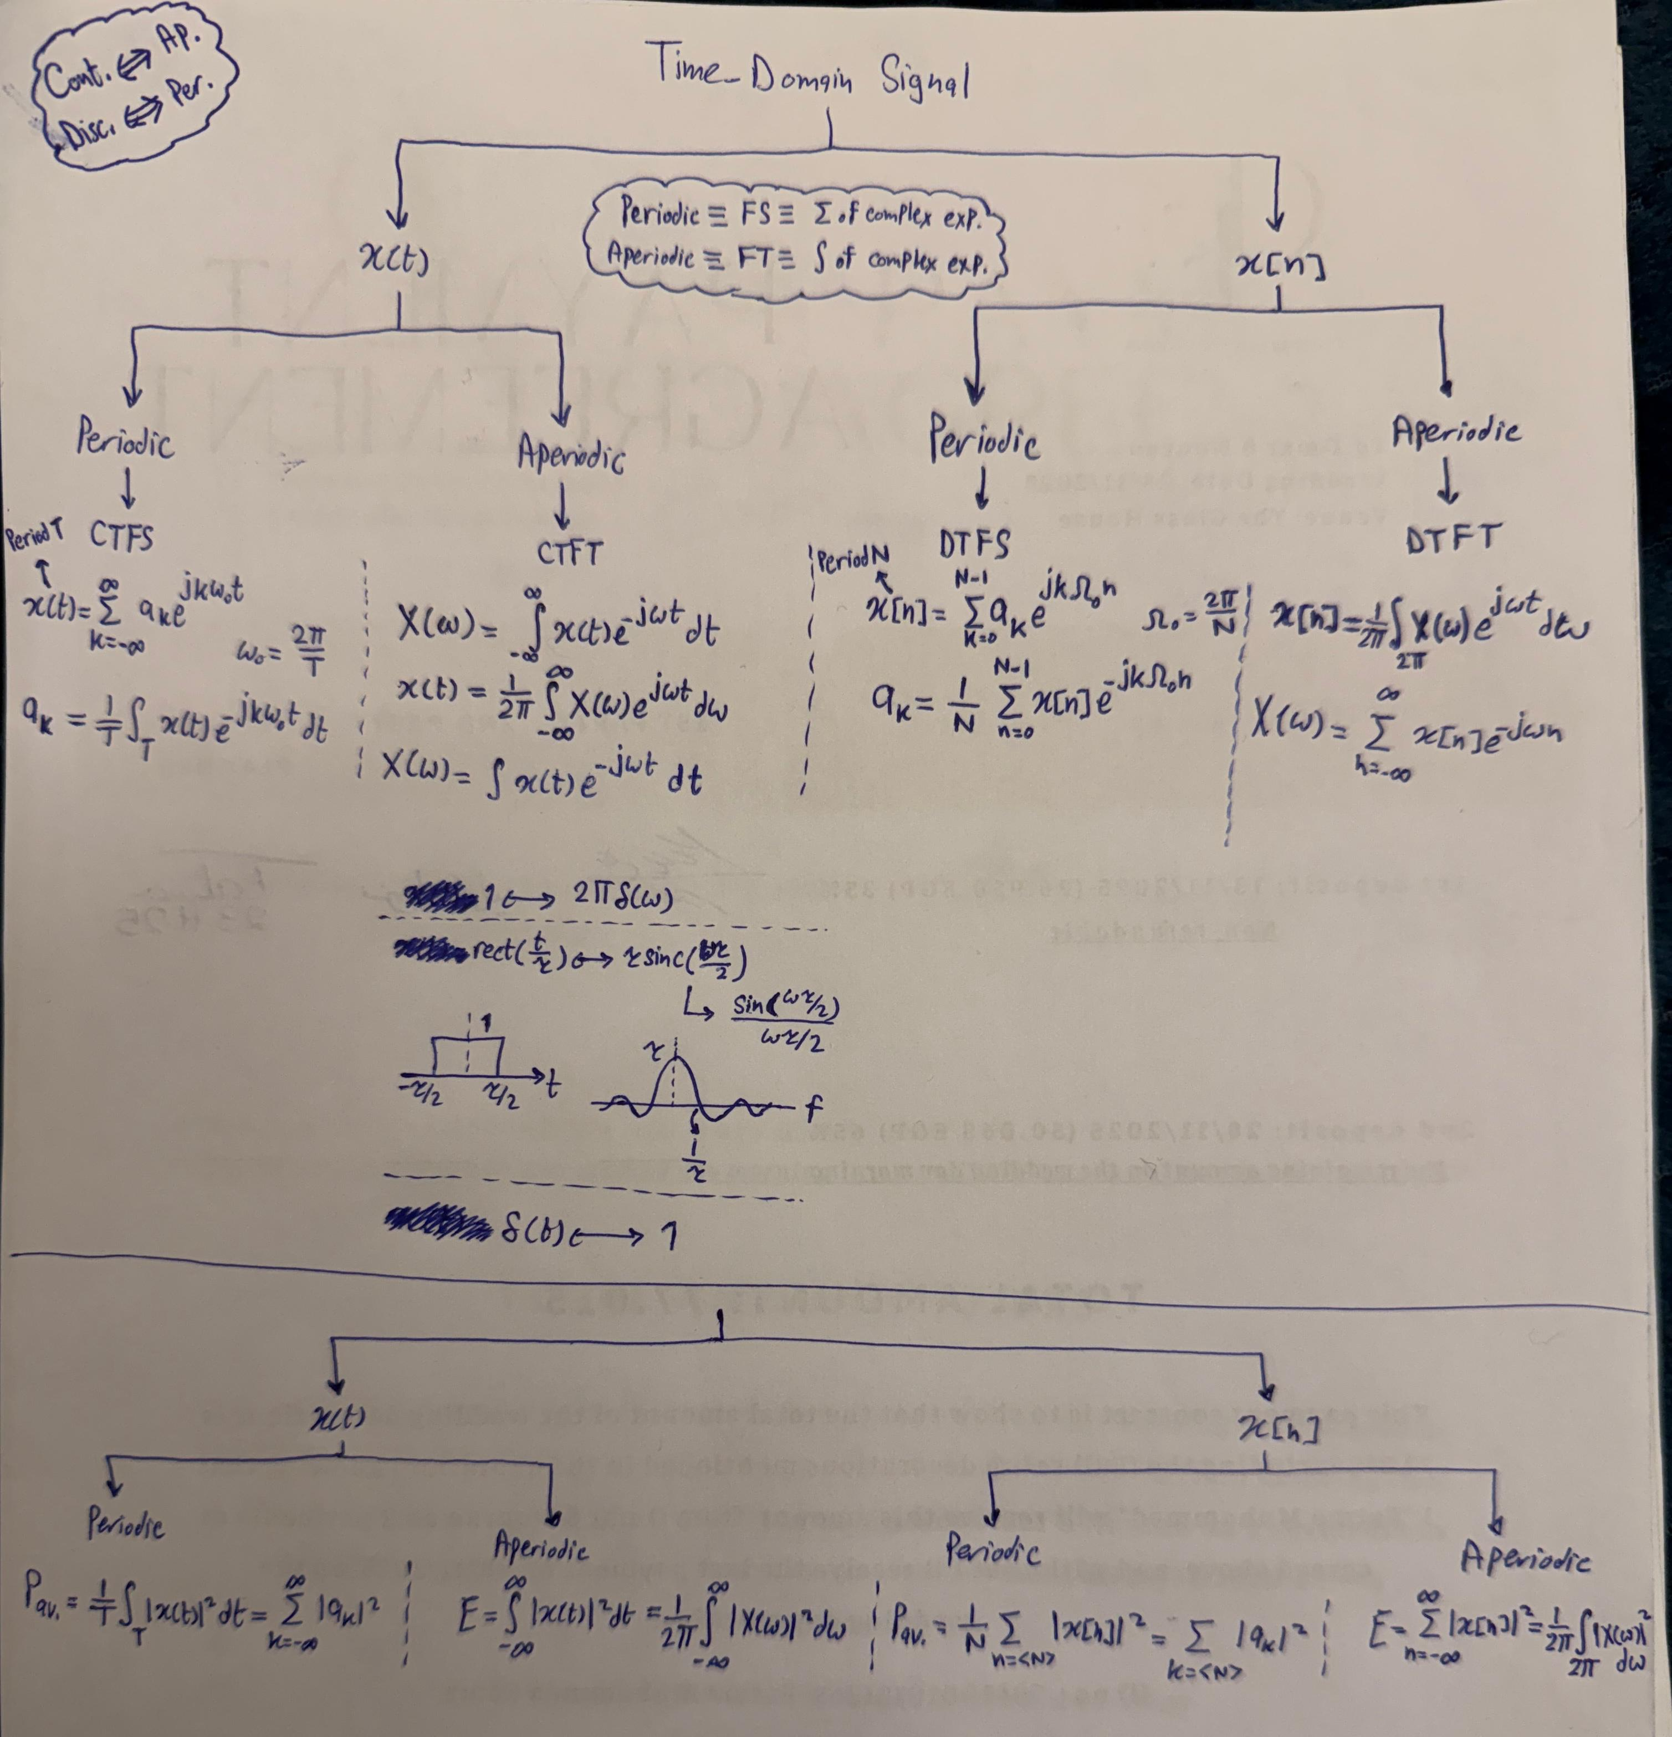
- Analog modulation: it is the process of varying an analog carrier signal (amplitude, phase, or frequency) in accordance with a message signal.
- Digital modulation: it is the process of mapping digital data (i.e. bits) onto analog waveforms by altering a carrier signal’s amplitude, phase, or frequency.
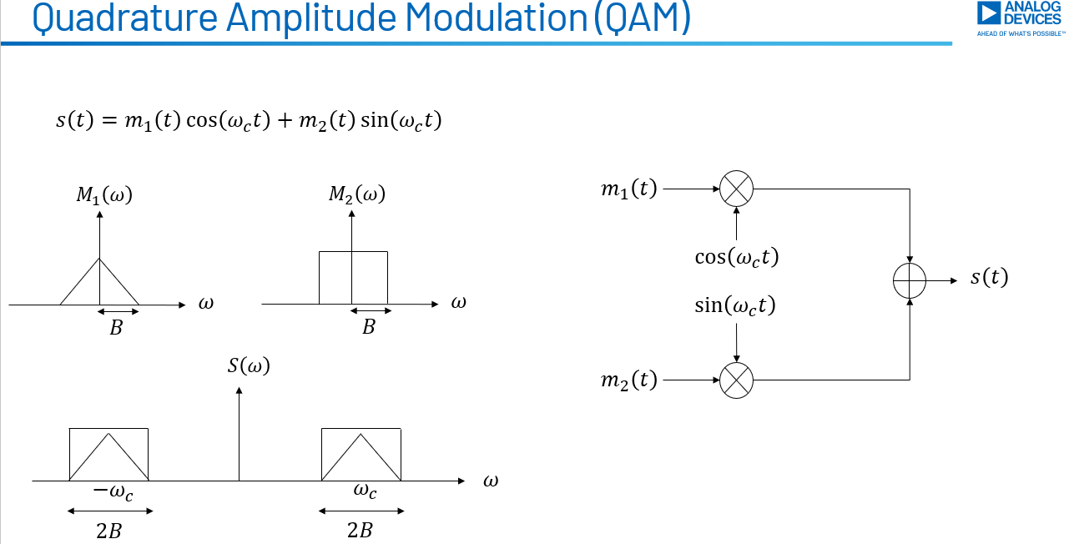
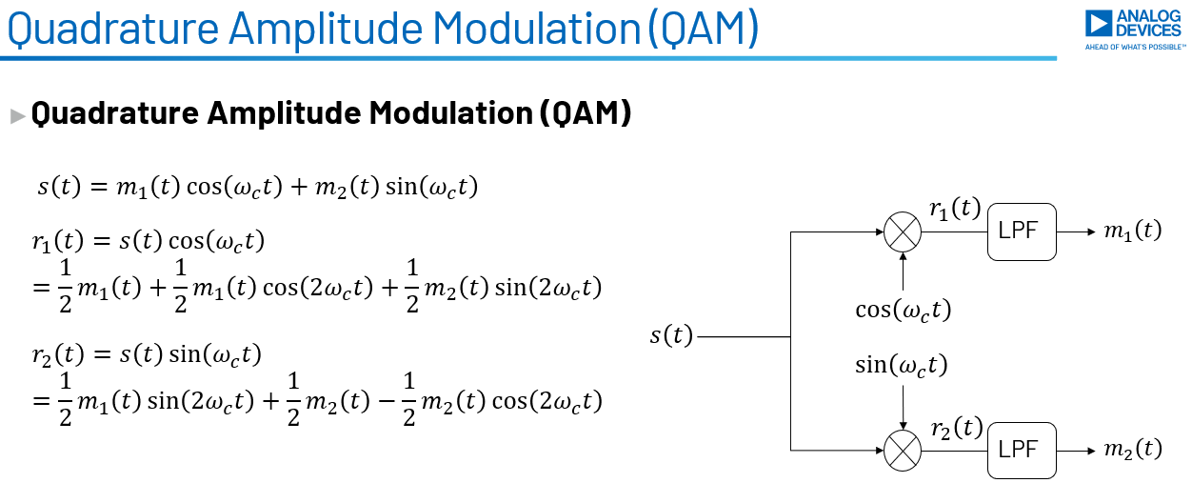
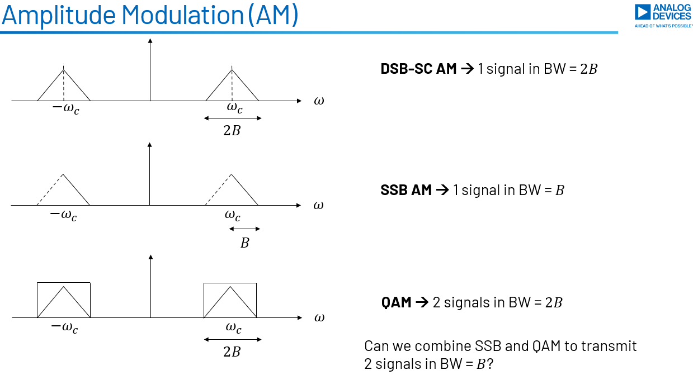
- To be able to reconstruct any signal (whether baseband or passband):
$$f_{s}≥2×BW$$
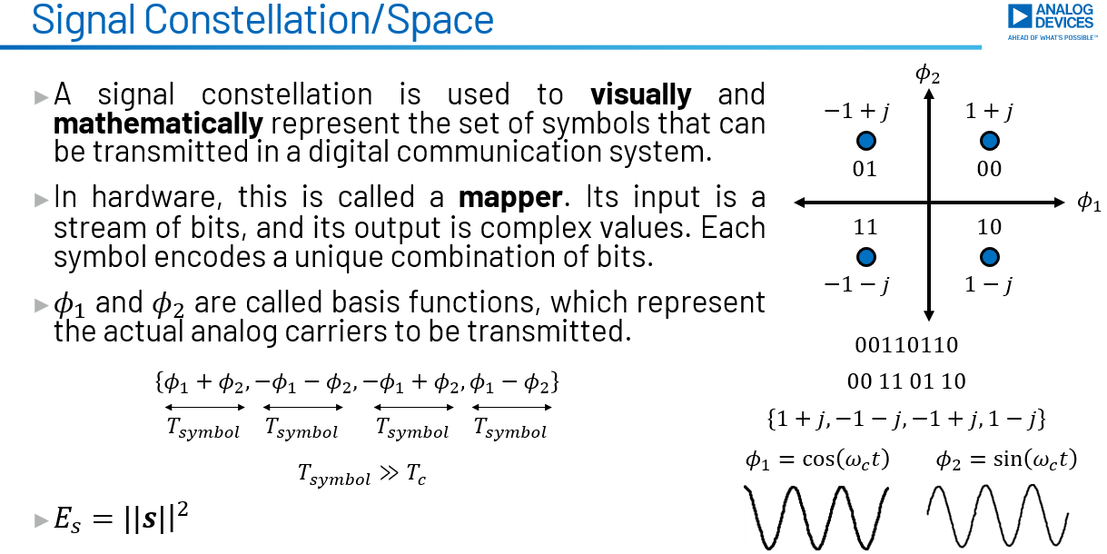
- The PSD of a staircase signal is $∝sinc^{2}\left(πfT_{symbol}\right)$. Thus, all modulation schemes result in the same PSD:
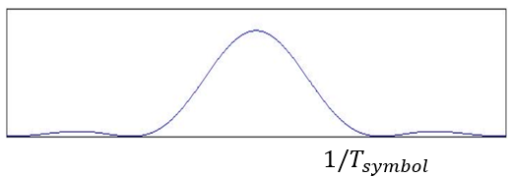
- We have two independent quantities: Energy and Rate:
  - Energy:
    - It can be symbol energy $E_{s}$ or bit energy $E_{b}$, where $E_{b}=\frac{E_{s}}{n}$ and $n=\log_{2}\left(M\right)$.
    - What decides energy is the symbol constellation. Taking M-PSK as an example, for the same modulation order, the farther the symbols are from each other (i.e. the wider the circle is), the higher the symbol energy and accordingly the bit energy. Or, the higher the modulation order for the same circle (which means same symbol energy), the lower the bit energy is.
  - Rate:
    - It can be symbol rate $R_{s}$ or bit rate $R_{b}$, where $T_{symbol}=nT_{bit}→R_{s}=\frac{R_{b}}{n}$ and $n=\log_{2}\left(M\right).$
    - $R_{s}=f_{clk}$ of the digital domain, so what decides the rate is the rate by which the digital domain transmits symbols to the DAC.
    - Symbol rate decides the bandwidth as $BW≈\frac{1}{T_{symbol}}=R_{s}$.
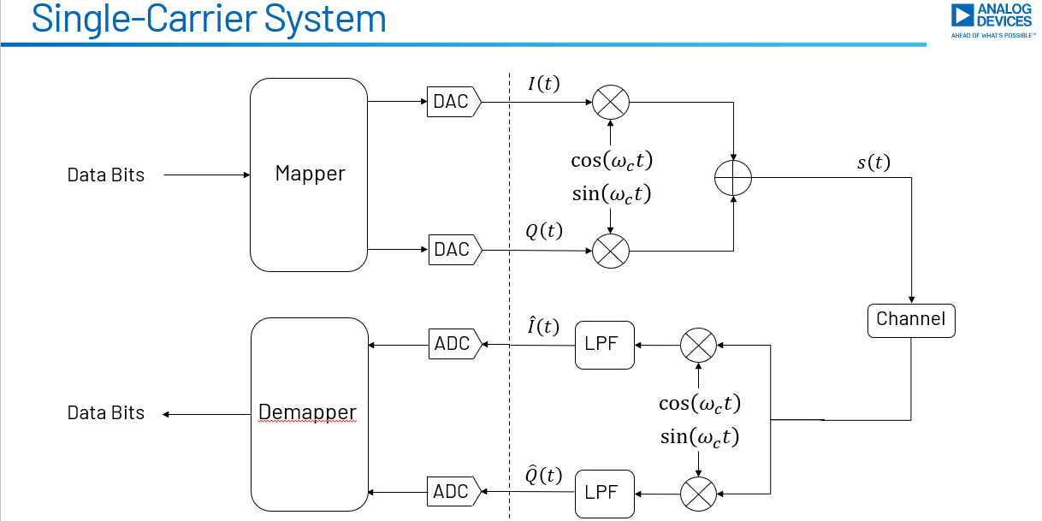

Internship – Session 2
- DFT:
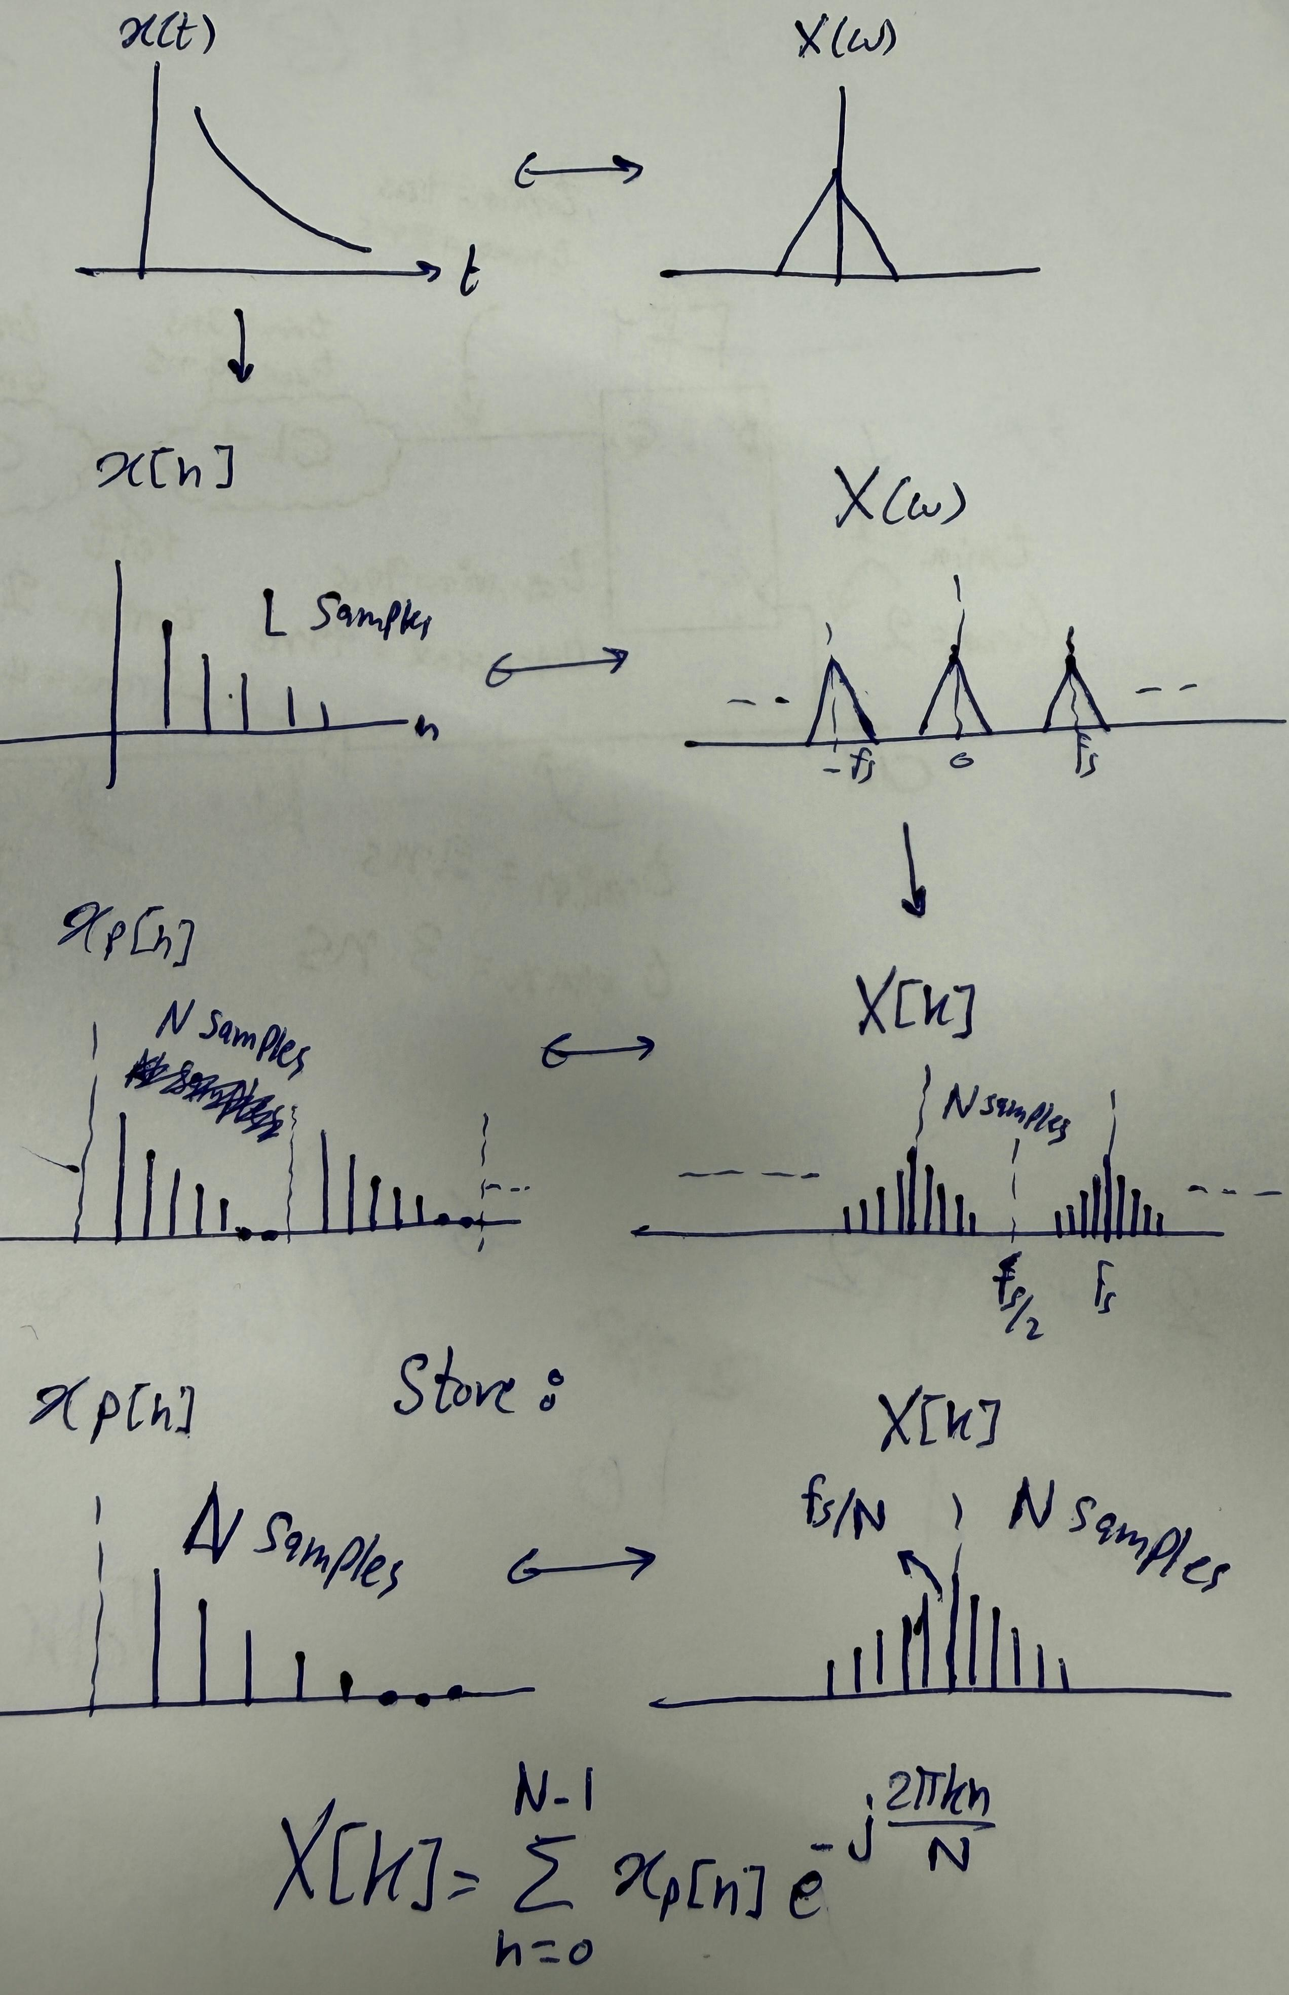
- $L$ defines how accurate the spectrum is. $N$ defines how smooth it looks.
- Going from single-carrier to FDM keeps the same data rate but makes the system more robust to ISI thanks to having each subcarrier seeing a smaller and hence flatter channel.
- Going from FDM to OFDM:
  - increases spectral efficiency since we pack more subcarriers in the same bandwidth.
  - results in higher data rate since we’re transmitting more symbols in the same symbol duration.
  - Makes the system more robust since each subcarrier became narrower and see flatter channel.
  - Has no negative impact on the errors since all subcarriers are orthogonal.
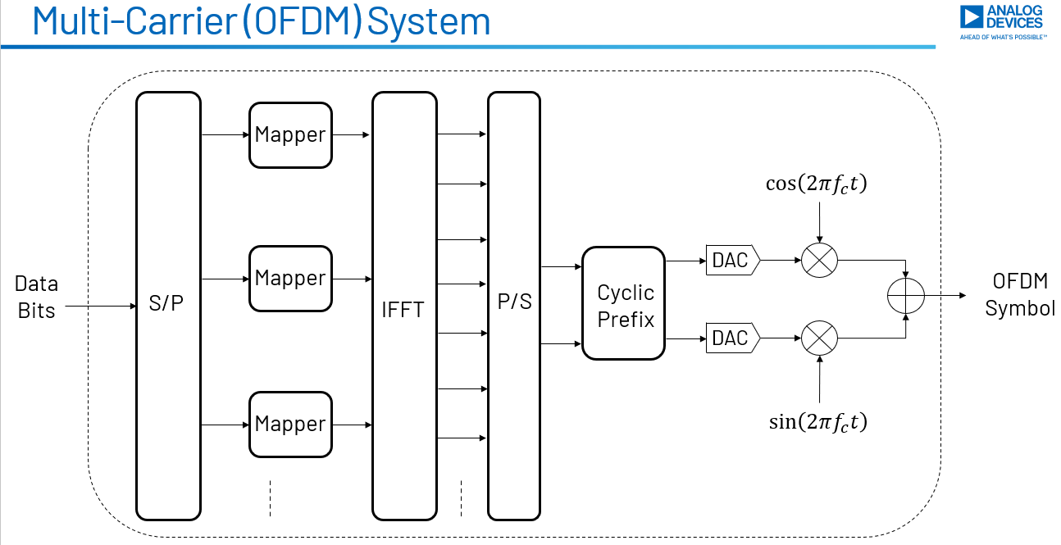

Internship – Session 3
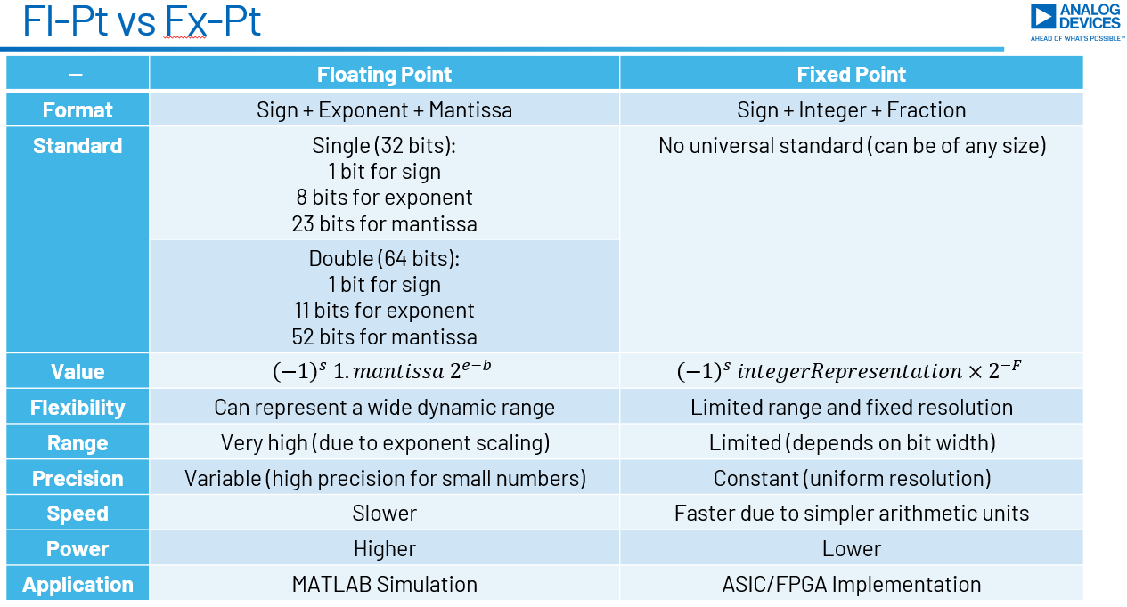
- Slides 10 to 19.

DPD
- A classical adaptive FIR filter is given by:
$$y\left[n\right]=\sum_{i=0}^{L-1}{h_{i}}x\left[n-i\right]$$
where the coefficients are updated over time (i.e. not constant) using adaptive algorithms (e.g. LS, LMS, NLMS, RLS).
- The DPD is the most sophisticated and advanced adaptive filtering system used in modern RF transmitters. Why? Because:
  - Its model is non-linear, not linear as the simple adaptive FIR filters.
  - The feedback path needed to adaptively update the coefficients introduces distortions.
  - To account for adjacent channels, a DPD system requires 2-4x oversampling which puts a burden on the digital implementation side.
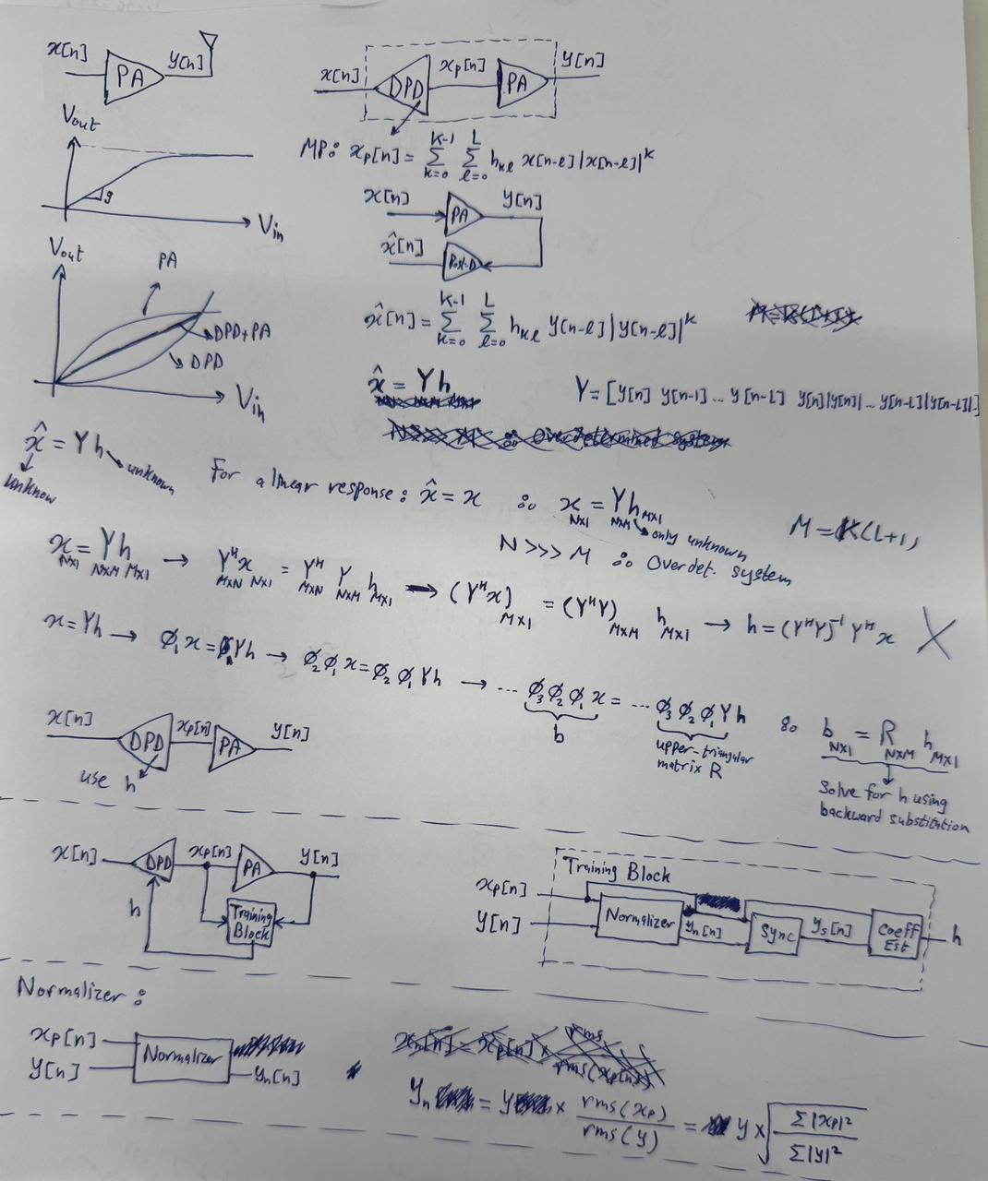
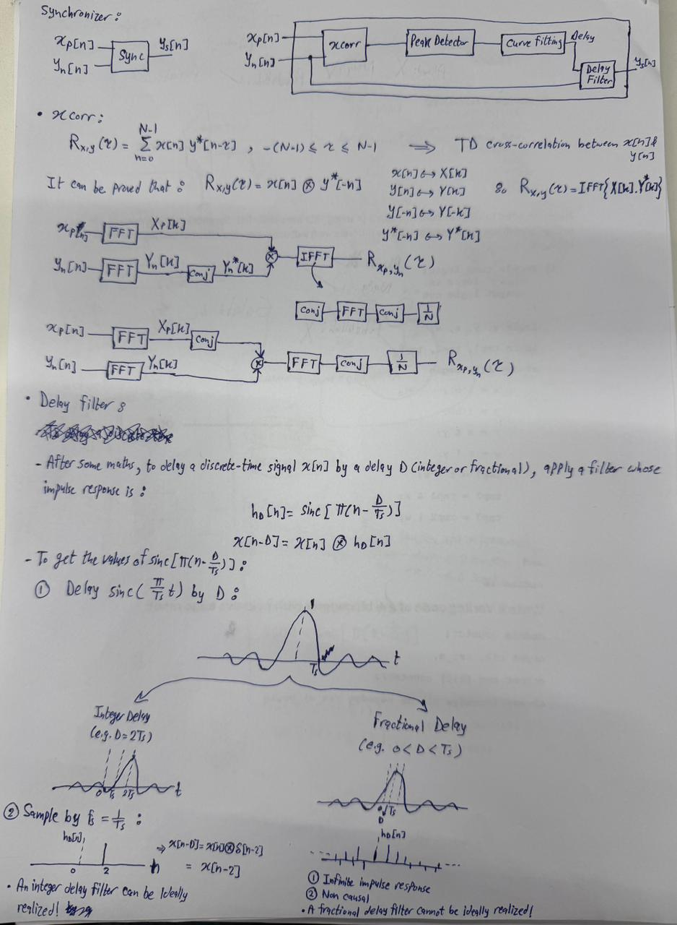
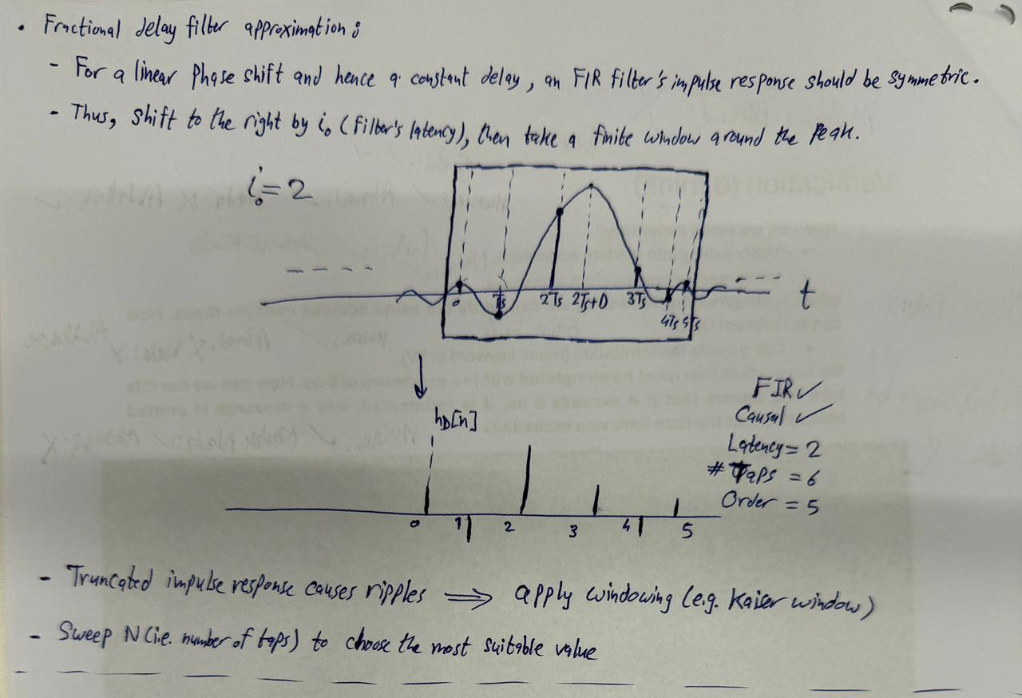
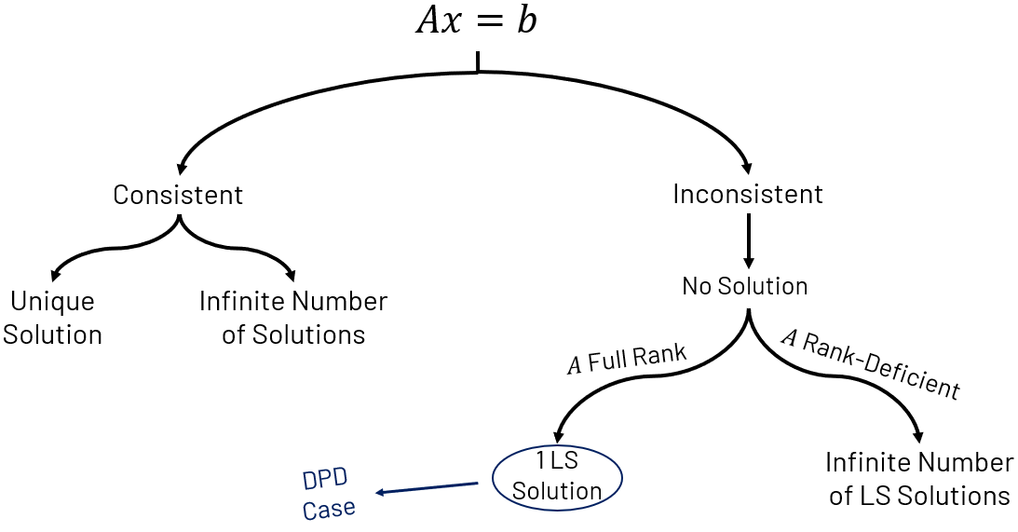
- The $Q$ matrix in QR is a unitary matrix (i.e. has a unity norm).
- Givens rotation rotates a vector $\left[\begin{matrix}A \\ B\end{matrix}\right]$ clockwise by an angle $θ$ while preserving the vector’s length (this is why it is called a unitary transformation) by multiplying by a unitary matrix:
$$\left[\begin{matrix}\cos{θ} & \sin{θ} \\ -\sin{θ} & \cos{θ}\end{matrix}\right]\left[\begin{matrix}A \\ B\end{matrix}\right]=\left[\begin{matrix}E \\ F\end{matrix}\right]$$
- To transform a 3x3 real matrix into an upper triangular matrix:
$$\left[\begin{matrix}A_{11} & A_{12} & A_{13} \\ A_{21} & A_{22} & A_{23} \\ A_{31} & A_{32} & A_{33}\end{matrix}\right]$$
$$Ψ_{1}\left[\begin{matrix}A_{11} & A_{12} & A_{13} \\ A_{21} & A_{22} & A_{23} \\ A_{31} & A_{32} & A_{33}\end{matrix}\right]=\left[\begin{matrix}A_{11}' & A_{12}' & A_{13}' \\ 0 & A_{22}' & A_{23}' \\ A_{31} & A_{32} & A_{33}\end{matrix}\right]$$
$$Ψ_{2}Ψ_{1}\left[\begin{matrix}A_{11} & A_{12} & A_{13} \\ A_{21} & A_{22} & A_{23} \\ A_{31} & A_{32} & A_{33}\end{matrix}\right]=\left[\begin{matrix}A_{11}'' & A_{12}'' & A_{13}'' \\ 0 & A_{22}' & A_{23}' \\ 0 & A_{32}' & A_{33}'\end{matrix}\right]$$
$$Ψ_{3}Ψ_{2}Ψ_{1}\left[\begin{matrix}A_{11} & A_{12} & A_{13} \\ A_{21} & A_{22} & A_{23} \\ A_{31} & A_{32} & A_{33}\end{matrix}\right]=\left[\begin{matrix}A_{11}'' & A_{12}'' & A_{13}'' \\ 0 & A_{22}'' & A_{23}'' \\ 0 & 0 & A_{33}''\end{matrix}\right]$$
$$Ψ_{3}Ψ_{2}Ψ_{1}A=R$$
$$A={\left(Ψ_{3}Ψ_{2}Ψ_{1}\right)}^{T}R$$
$$Q={\left(Ψ_{3}Ψ_{2}Ψ_{1}\right)}^{T}$$
- To transform a 3x3 complex matrix into an upper triangular matrix:
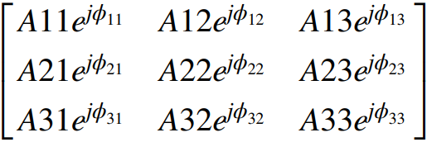
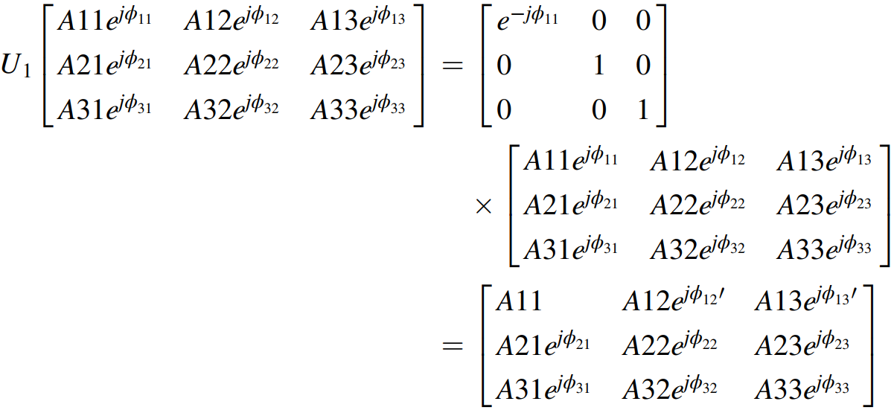
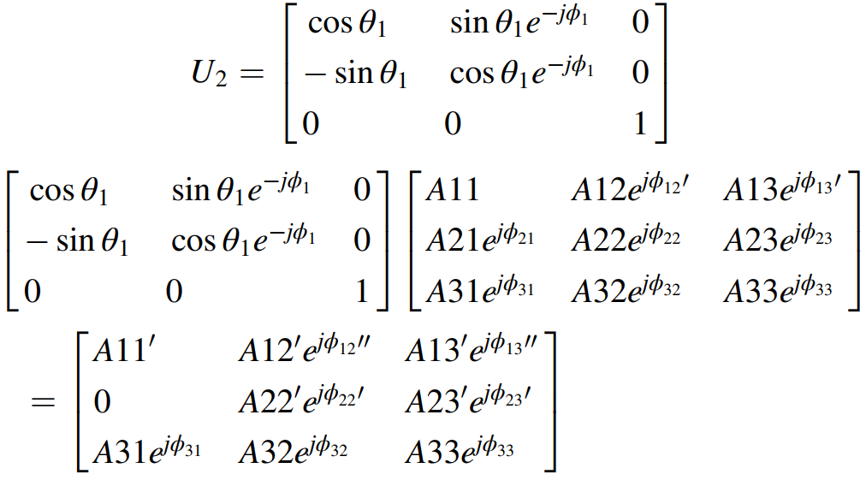
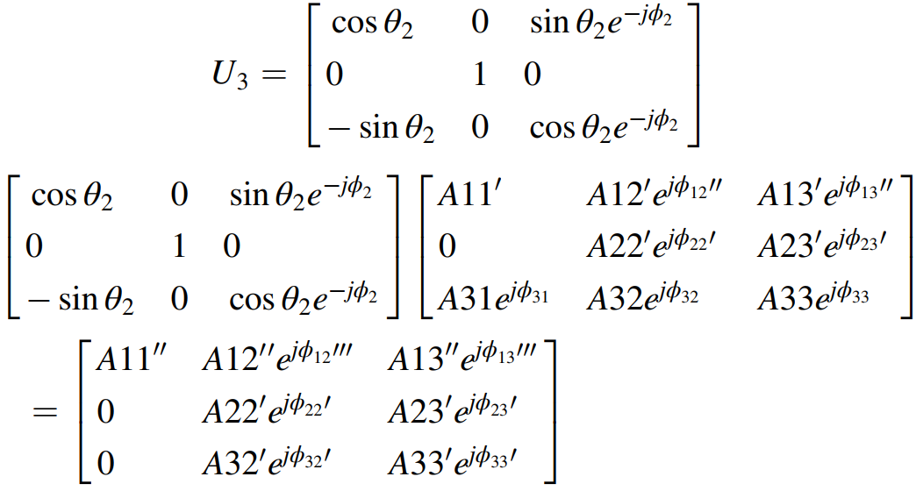
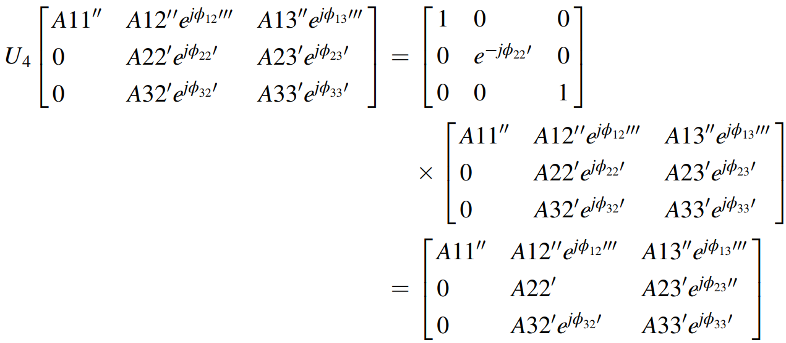
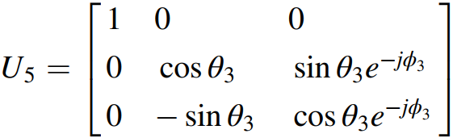
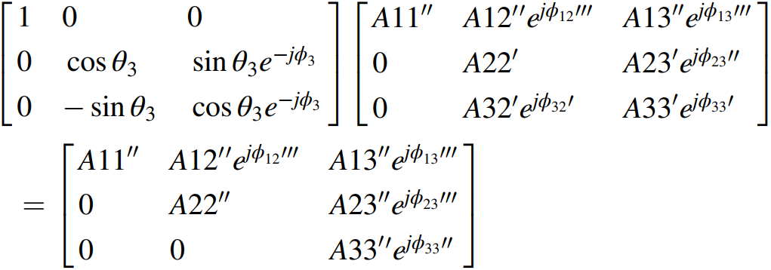
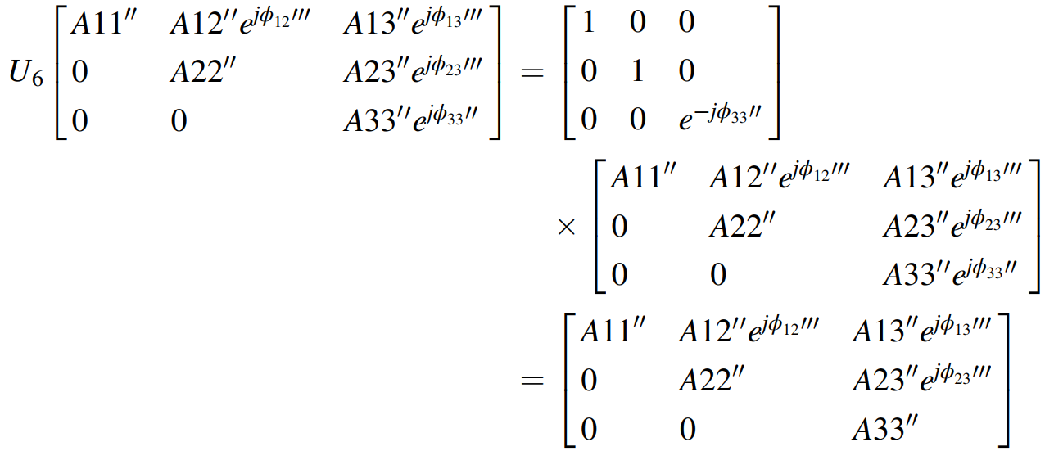
$$U_{6}U_{5}U_{4}U_{3}U_{2}U_{1}A=R$$
$$A={\left(U_{6}U_{5}U_{4}U_{3}U_{2}U_{1}\right)}^{-1}R$$
$$A=U_{1}^{H}U_{2}^{H}U_{3}^{H}U_{4}^{H}U_{5}^{H}U_{6}^{H}R$$
$$Q=U_{1}^{H}U_{2}^{H}U_{3}^{H}U_{4}^{H}U_{5}^{H}U_{6}^{H}$$

